Product/Product Category Description 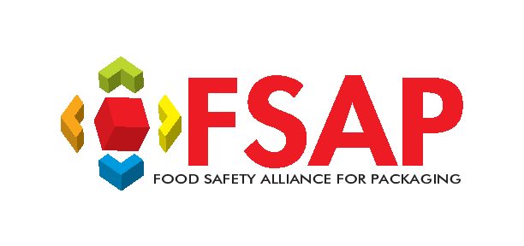
Facility Name: |  | Date:
Product/Product Category
Process
Food Safety Characteristics
Customer Use
Target Market/Consumer
General Raw Materials
Packaging/Palletization
Shelf Life
Storage & Distribution
Other

